PROJECT REPORT

Unearthing the environmental impact

of human activity: A Global CO2 emission Analysis

1.Introduction

1.1 Overview

Global warming is one of the biggest challenges currently being faced by human race.Cause of Global warming is due to increased atmospheric carbon dioxide from human activities. CO2 emission refers to the carbon dioxide emitted throughout the world.fossil fuel use is the primary source of CO2.

Analysing global CO2 emission across countries from 1975 to 2020. This dataset contains a record of CO2 emission by each country and region of the earth.

1.2 Purpose

Measuring CO2 emissions allows you to determine carbon reduction oppurtunities,usually linked to energy and transportation.Measuring your carbon footprint is the first step toward a successful environmental journey. It highlights the fact that reduction measures exist and can be implemented.

2 Problem definition and design thinking



2.2 Ideation and brainstorming map



3 Result

Activity and Screenshots

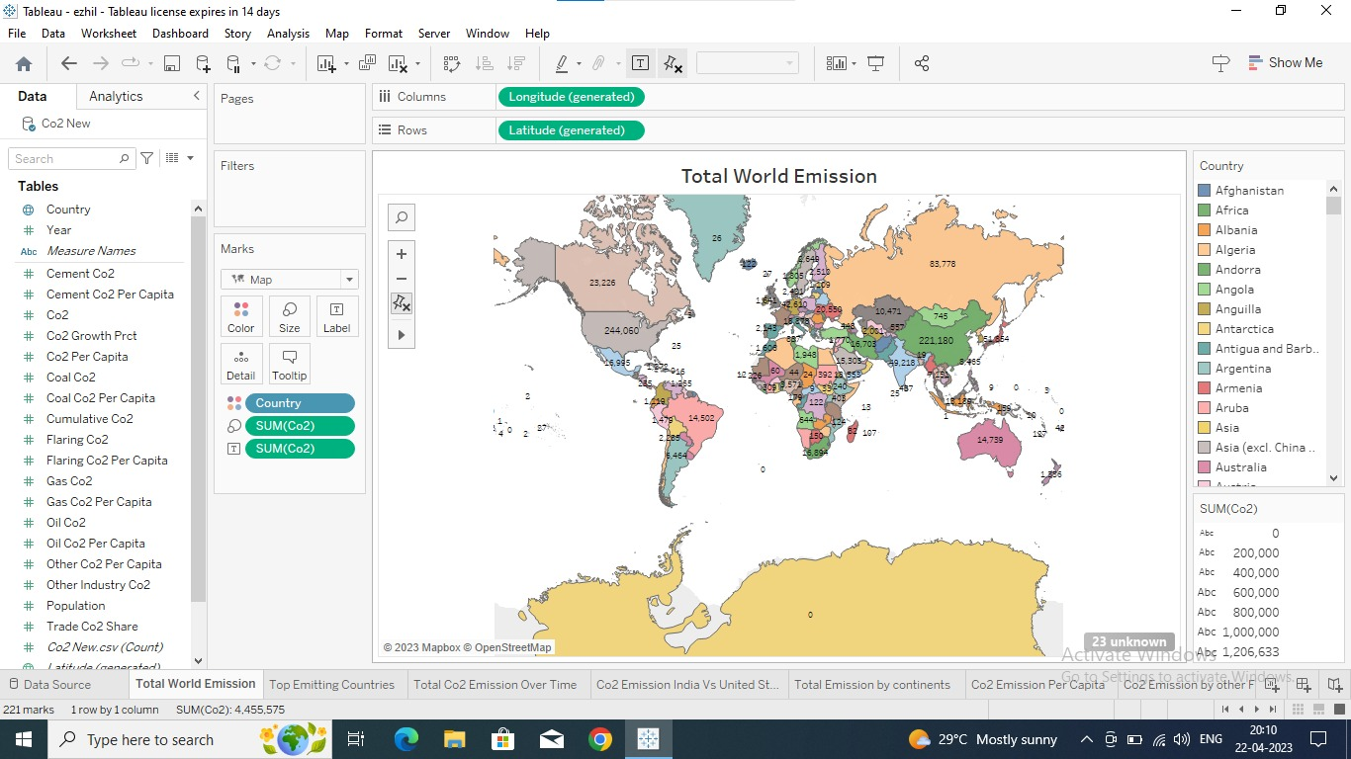

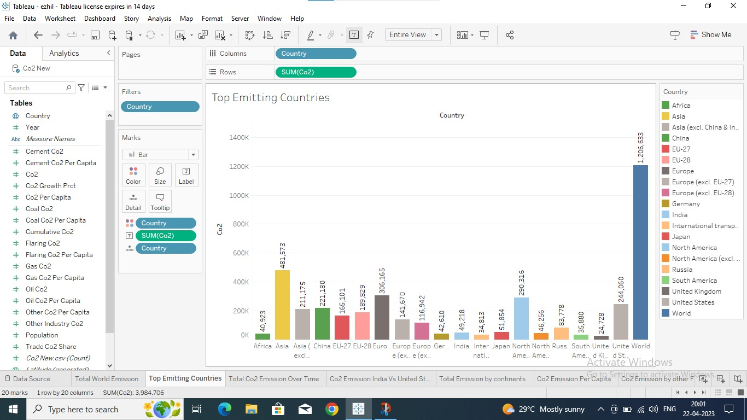

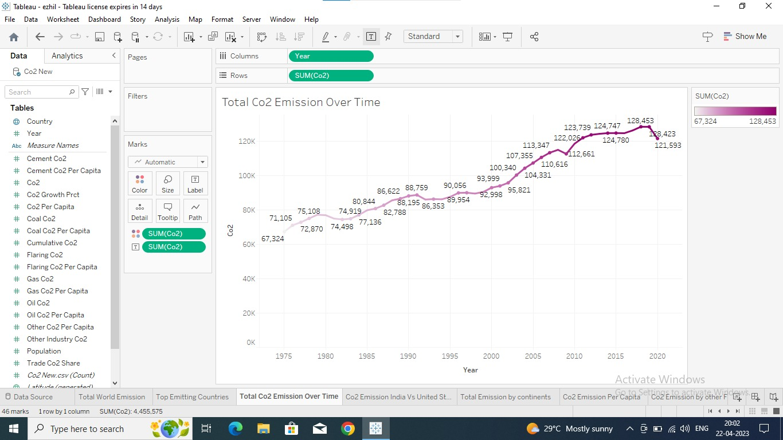

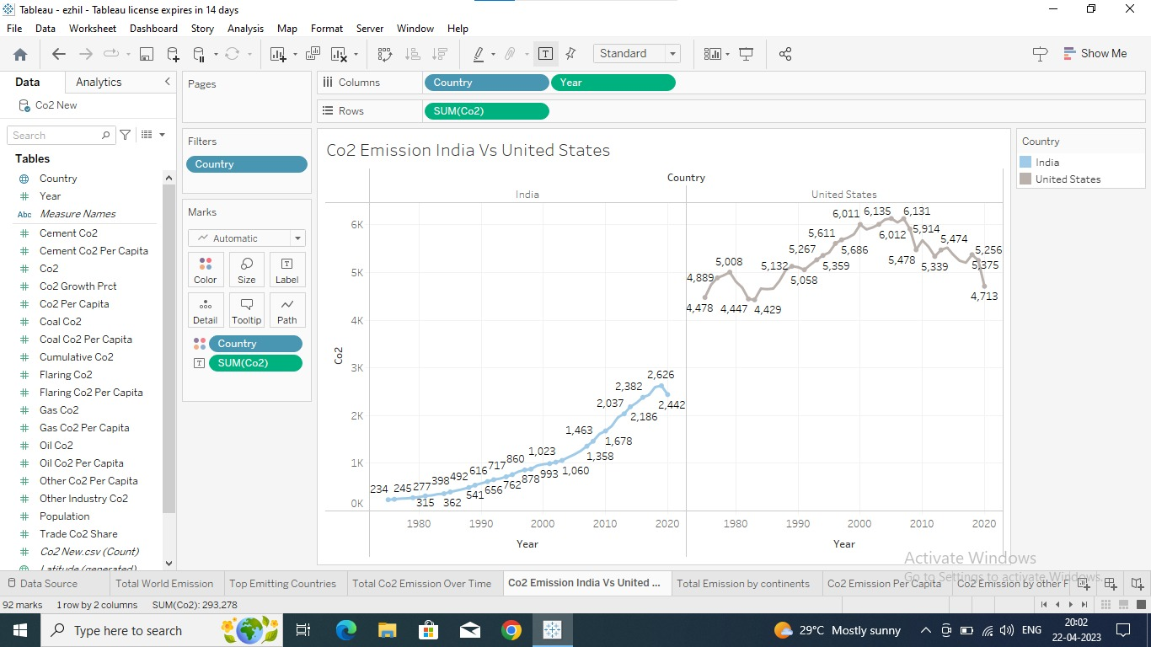

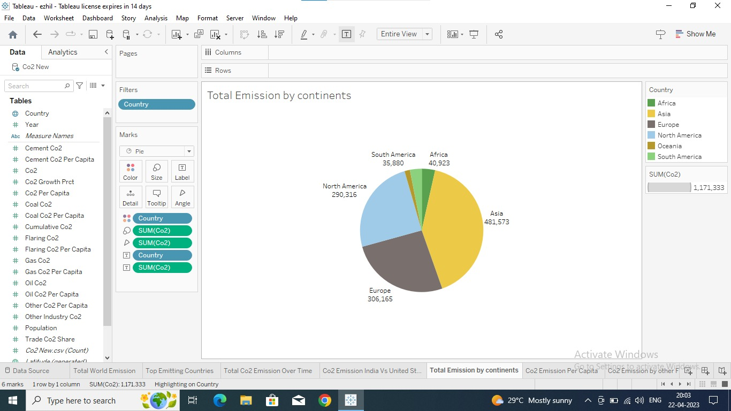

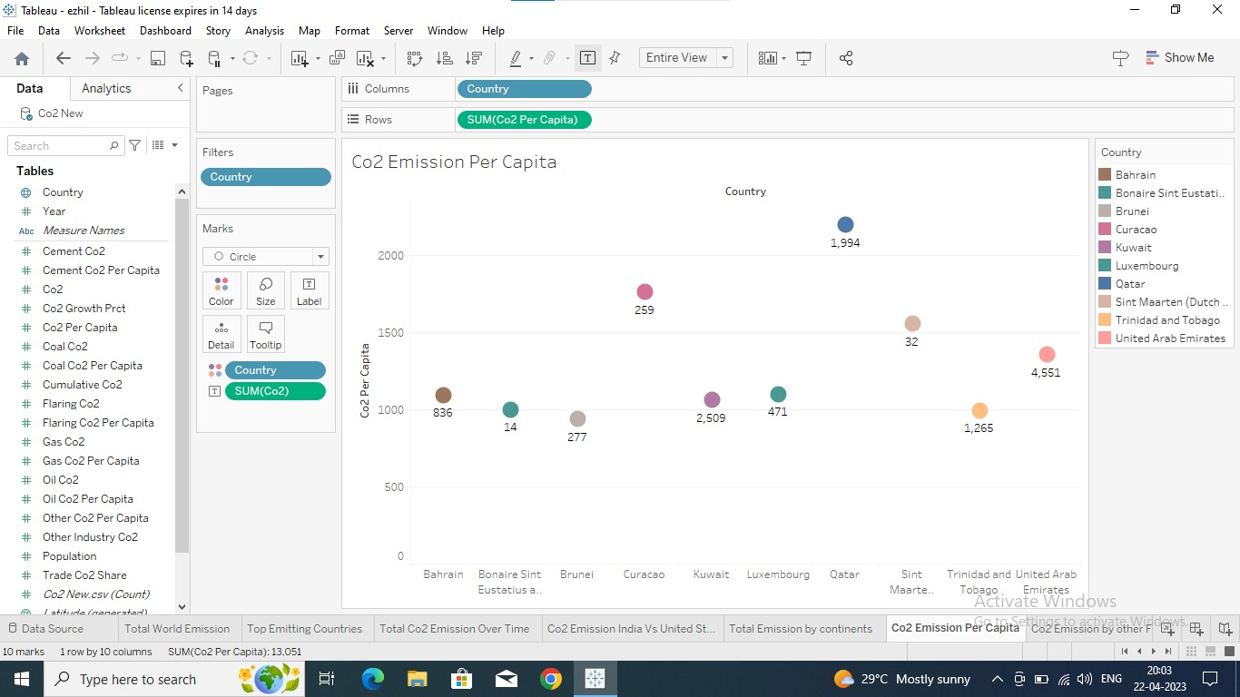

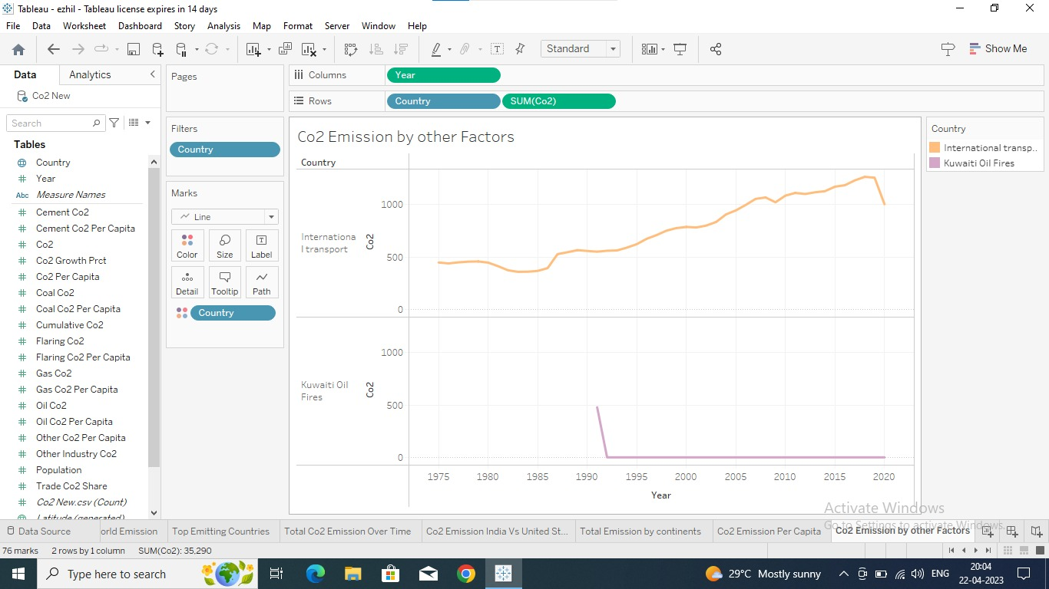

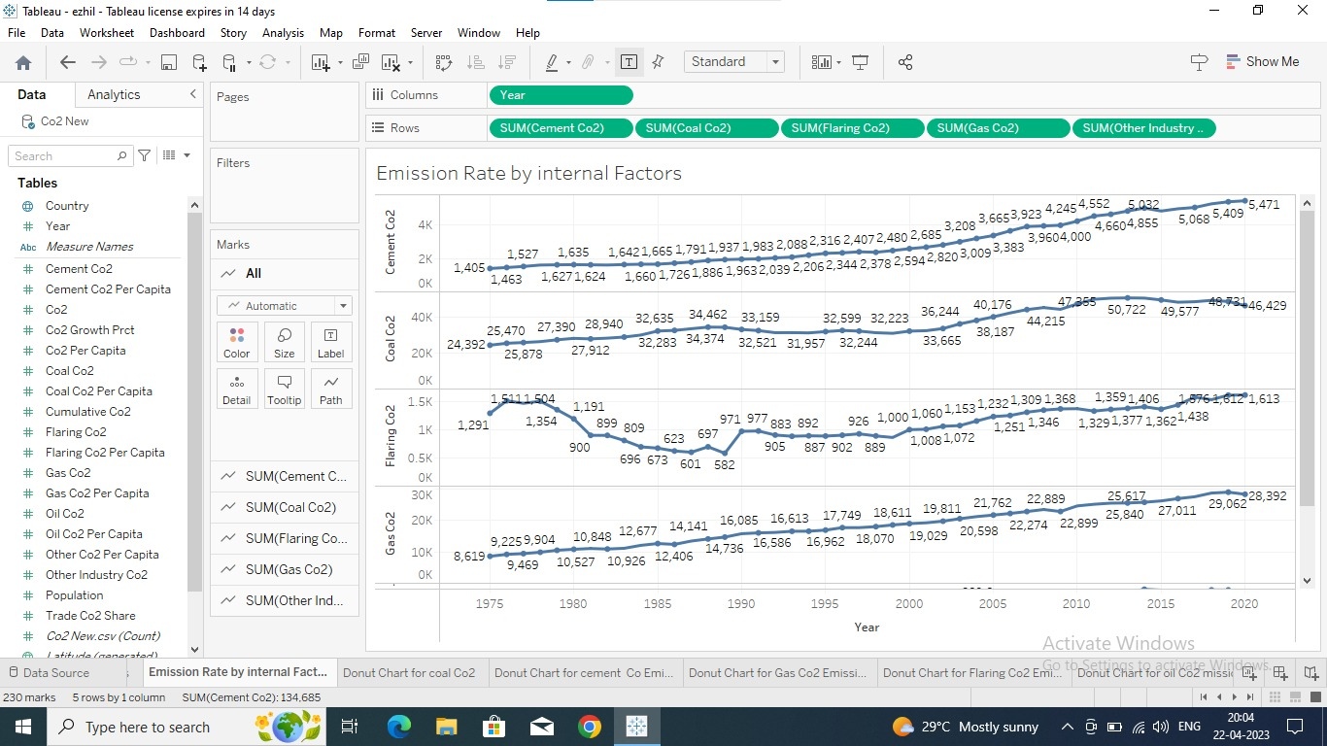

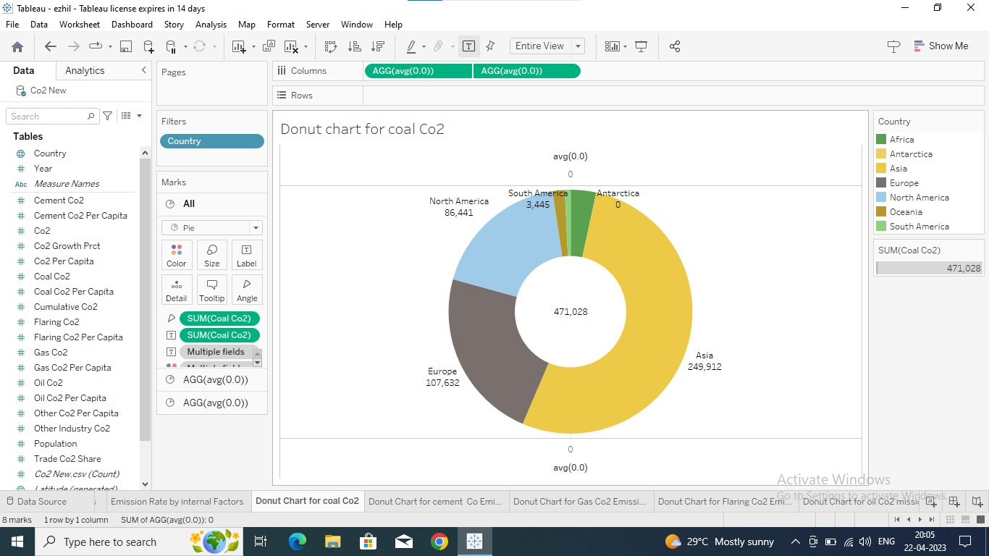

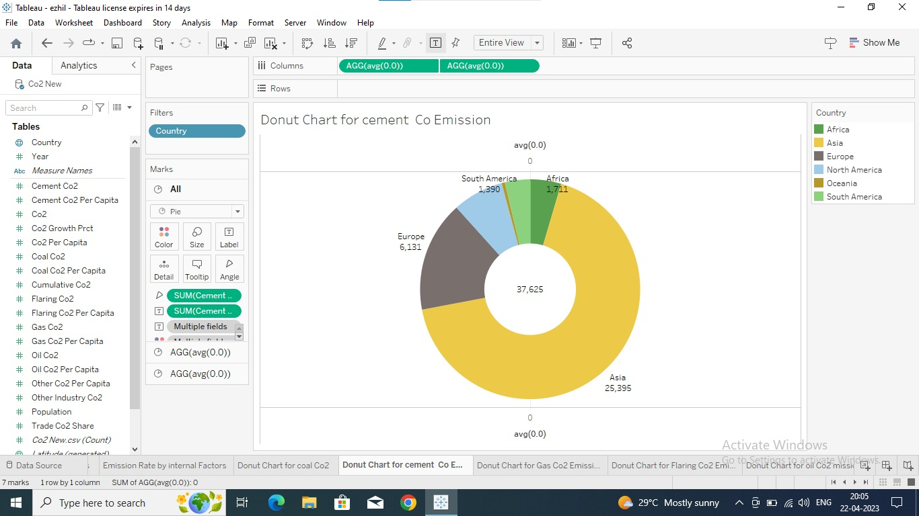

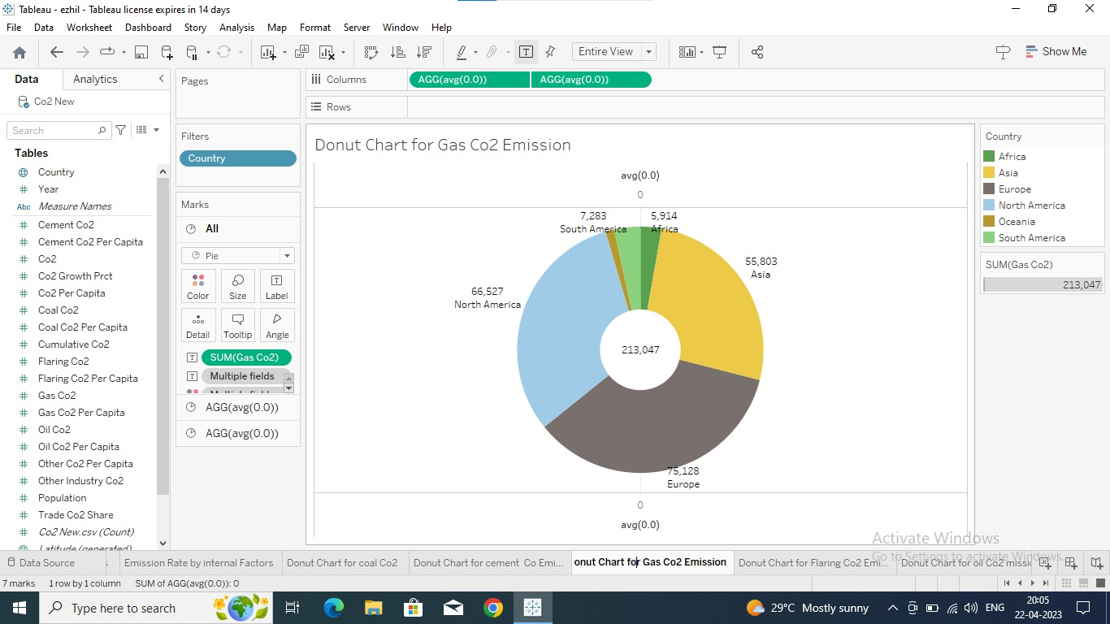

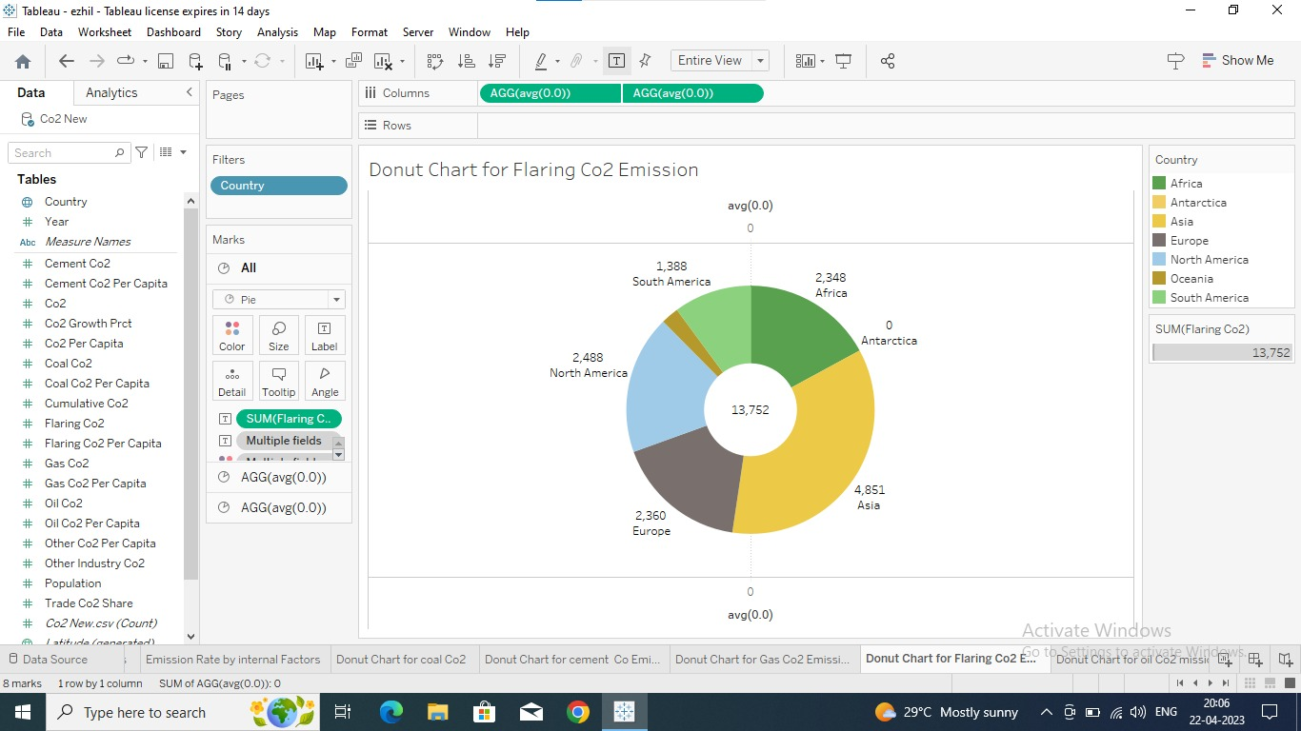

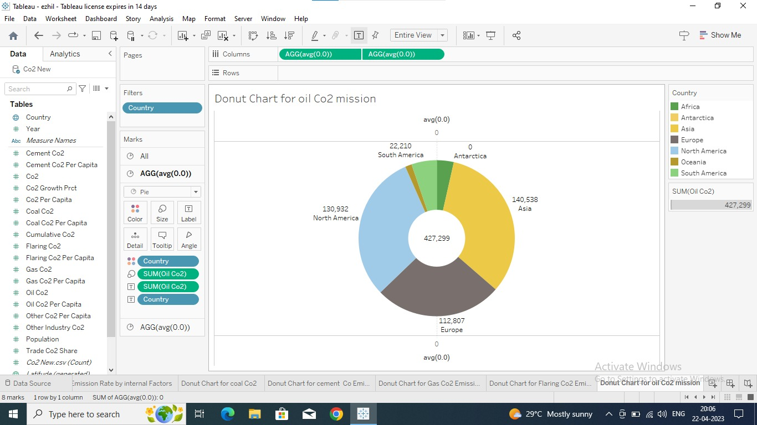

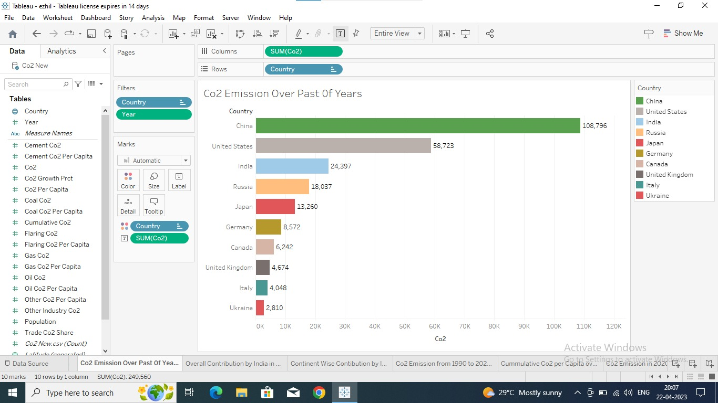

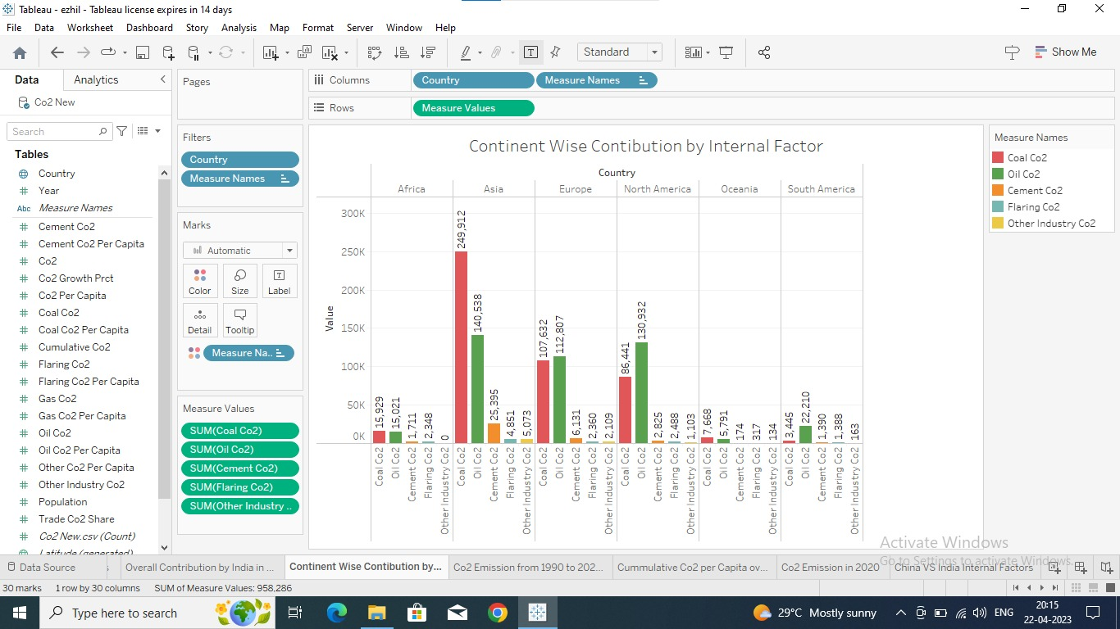

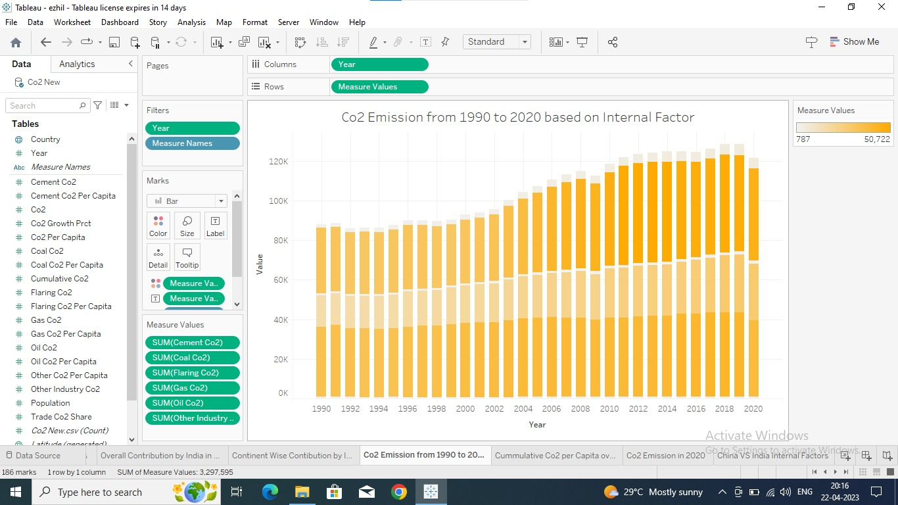

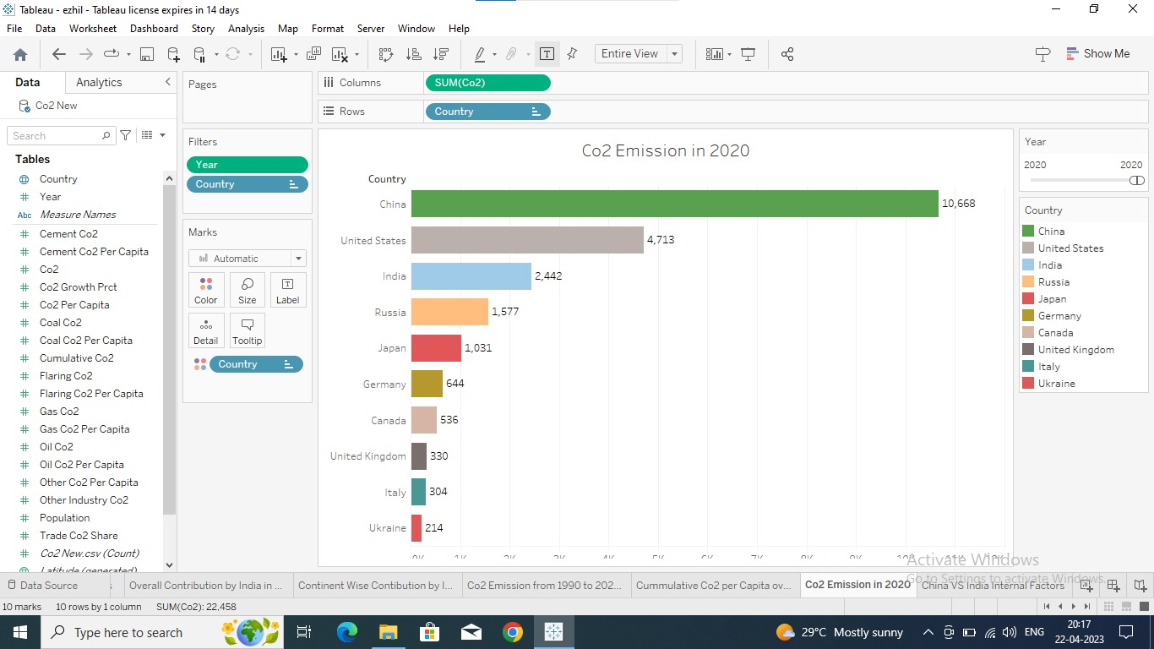

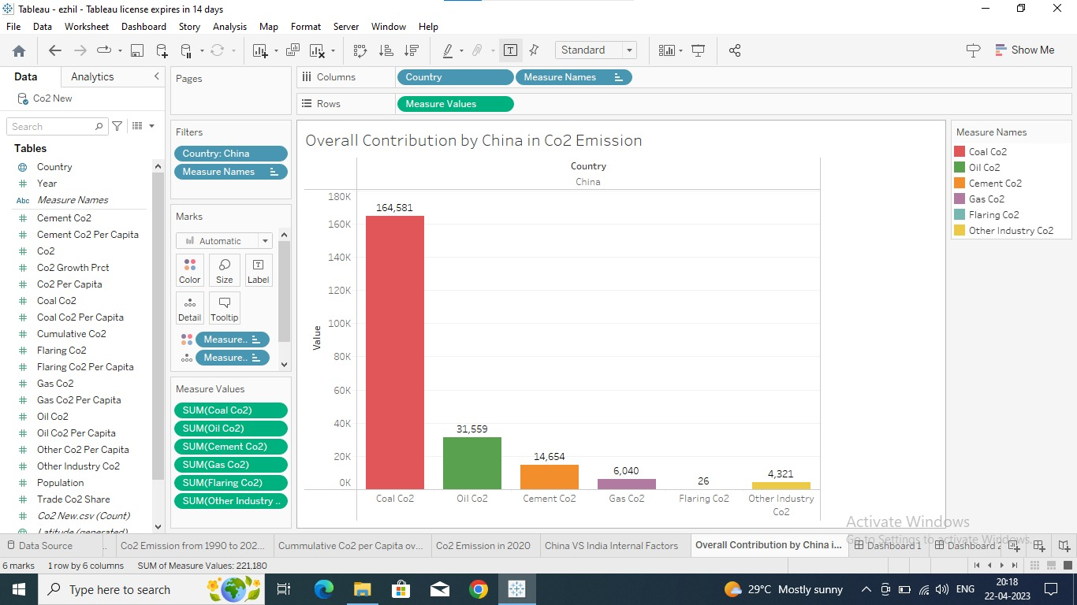

4 Trailhead profile public URL

Team Lead-

<https://trailblazer.me/id/obuharipriya9876>

Team Member 1-

<https://trailblazer.me/id/kanimozhi9876>

Team Member 2-

<https://trailblazer.me/id/shalini98765>

Team Member 3-

<https://trailblazer.me/id/ezhilkumaar9876>

5 Advantage and Disadvantage

By analysing the CO2 emission we able to control it.Manage emissions originating from any source and enables the direct Extraction of CO2 from the atmosphere. At least 85% adsorption efficiency is achievable.

Analysing CO2 emission requies an great energy source and it’s expensive. Large volumes of air must be processed in order to collect meaningful amounts of CO2.

6 Main source of Carbon dioxide emission

Human activities such as burning of oil, coal and gas, as well as deforestation are the primary cause of the increased carbon dioxide concentration in the atmosphere. 87% of all human produced carbon dioxide emissions come from the burning of the fossil fuels like coal,natural gas and oil.

7 The Conclusion

In Conclusion, Analysing CO2 emission will helps to reduce CO2 emission and it’s a main source for carbon sequestration,is used to reduce the amount of carbon dioxide in the atmosphere and with the goal of reducing global climate change.

We can analyse CO2 by infrared detectors, also known as NDIR analyzers, can be used to measure CO2 because it is an excellent absorber of infrared energy.

To put it in a Nutshell, Analysing CO2 emission is a predominant thing in this era,By Analysing we may have the chance to reduce it.